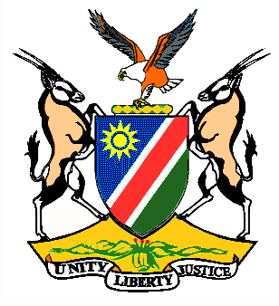

EMBASSY/PERMANENT MISSION OF THE REPUBLIC OF NAMIBIA

REPUBLIC OF NAMIBIA

Statement by H.E. Sabine Böhlke-Möller, Permanent Representative during the Interactive Dialogue on the Universal Periodic Review of Papua New Guinea, 06 May 2016, 09h00 – 12h30

Mr. President,
Namibia welcomes the delegation of Papua New Guinea to this Session of the UPR and commends them on the presentation of their national report. Namibia is honored to be part of the Troika for this review.
We commend the Government of Papua New Guinea for the reforms, which brought their domestic legislation in line with international human rights instruments, including the adoption of the Family Protection Act in 2013, which criminalized domestic violence.
Namibia is pleased to take note of the progress made with the National Policy on Child Protection and the adoption of the Gender Equity and Social Inclusion Policy and the National Policy on Disability wish the Government of Papua New Guinea success with the implementation thereof.
Whilst taking note that the last execution in Papua New Guinea was carried out in 1953, we express concern over reports that the Government intents to start implementing capital punishment in response to the high level of violence in the country.
Namibia would like to recommend:
1. That the Government of Papua New Guinea considers ratification of the second optional Protocol to the ICCPR with a view to abolish the death penalty;
2. That the Government of Papua New Guinea takes active measures to ensure full and effective participation of women at all levels of public and political life.
We wish Papua New Guinea all the best during their review.
I thank you Mr. President.

